Every day, we come across different types of computer software that helps us with our tasks and increase our efficiency. From MS Windows that greets us when we switch on the system to the web browser that is used to surf the internet or the games that we play on our computer to the calorie burn counter on our smartphone, are all examples of software. In this world of technology, we even come across various [software development trends](https://squareboat.com/blog/5-ground-breaking-software-development-trends-ruling-2019) that help our business to grow, we are surrounded by all these software which are determined to make our lives easier. By definition, a Software (also abbreviated as an SW or S/W) is a collection of data, programs, procedures, instructions, and documentation that perform various predefined tasks on a computer system. They enable users to interact with the computer

In the field of software engineering and computer science, the software is nothing but information processed by a computer system and programs. The software includes libraries, programs, and corresponding non-executable data, such as digital media and online documentation. Computer hardware and software need each other and neither one of them can be convincingly used on its own. The amalgamation of the hardware and the software gives control and flexibility to modern-day computing systems. Without software, computers would be of no use. For instance, without the help of your web browser software, you will not be able to surf the Internet. Similarly, without an operating system, no application can run on your computer.

Today there are abundant high-end technologies and software accessible to us that outline the way we lead our lives and house our continuously changing and increasing needs. The endless number of software types can be overwhelming for anybody, especially when one does not understand the various types of software and their users thoroughly.

Different Types of Software

Typically, there are two major classifications of software, namely System Software and Application Software.

1. System Software

A system software aids the user and the hardware to function and interact with each other. Basically, it is a software to manage computer hardware behavior so as to provide basic functionalities that are required by the user. In simple words, we can say that system software is an intermediator or a middle layer between the user and the hardware. These computer software sanction a platform or environment for the other software to work in. This is the reason why system software is very important in managing the entire computer system. When you first turn on the computer, it is the system software that gets initialized and gets loaded in the memory of the system. The system software runs in the background and is not used by the end-users. This is the reason why system software is also known as ‘low-level software’.

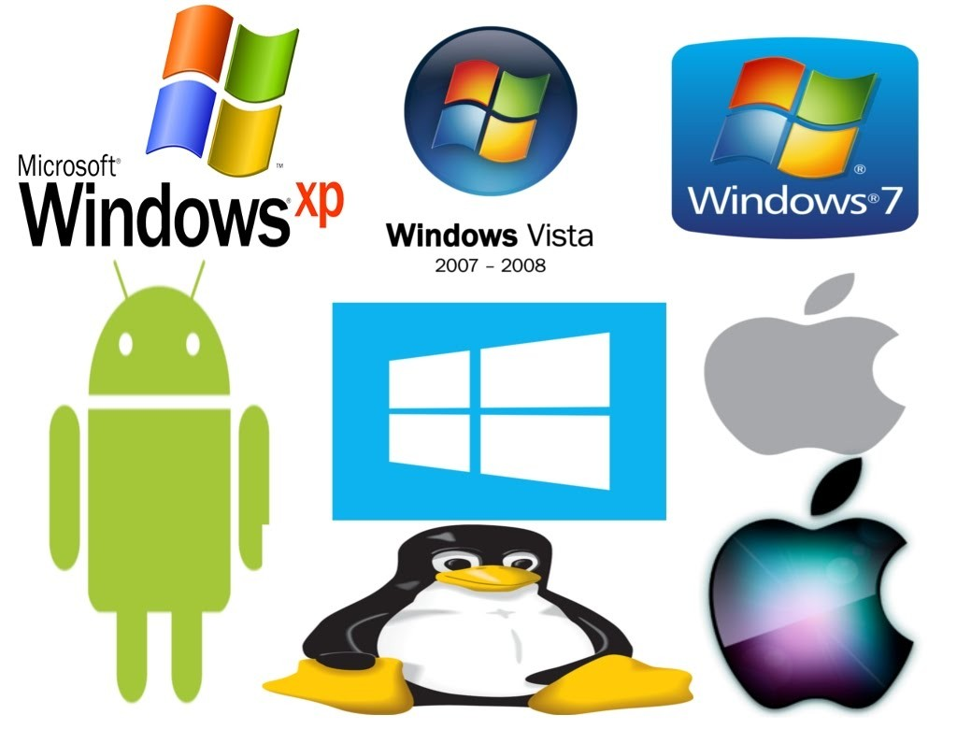[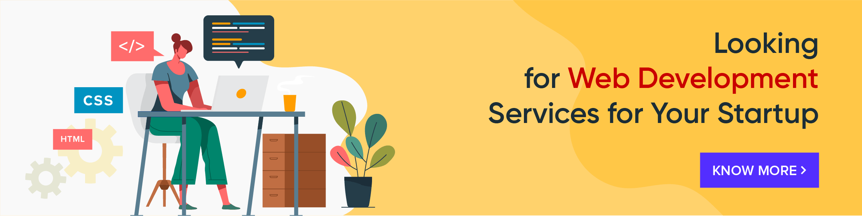](https://squareboat.com/tech-stack/web-development?ref=blog-post)

Some common system software examples are:

* Operating System: It is the most prominent example of System Software. It is a collection of software that handles resources and provides general services for the other applications that run over them. Although each Operating System is different, most of them provide a Graphical User Interface through which a user can manage the files and folders and perform other tasks. Every device, whether a desktop, laptop or mobile phone requires an operating system to provide the basic functionality to it. As an OS essentially determines how a user interacts with the system, therefore many users prefer to use one specific OS for their device. There are various types of operating system such as real-time, embedded, distributed, multiuser, single-user, internet, mobile, and many more. It is important to consider the hardware specifications before choosing an operating system. Some examples of Operating systems given below:
  + Android
  + CentOS
  + iOS
  + Linux
  + Mac OS
  + MS Windows
  + Ubuntu
  + Unix
* Device Drivers: It is a type of software that controls particular hardware which is attached to the system. Hardware devices that need a driver to connect to a system include displays, sound cards, printers, mice and hard disks. Further, there are two types of device drivers: Kernel Device Drivers and User Device Driver. Some examples of device drivers are:
  + BIOS Driver
  + Display Drivers
  + Motherboard Drivers
  + Printer Drivers
  + ROM Drivers
  + Sound card Driver
  + USB Drivers
  + USB Drivers
  + VGA Drivers
  + VGA Drivers
  + Virtual Device Drivers
* Firmware: [Firmware](https://en.wikipedia.org/wiki/Firmware) is the permanent software that is embedded into a read-only memory. It is a set of instructions permanently stored on a hardware device. It provides essential information regarding how the device interacts with other hardware. Firmware can be considered as ‘semi-permanent’ as it remains permanent unless it is updated using a firmware updater. Some examples of firmware are:
  + BIOS
  + Computer Peripherals
  + Consumer Applications
  + Embedded Systems
  + UEFI
* Programming Language Translators: These are mediator programs on which software programs rely to translate high-level language code to simpler machine-level code. Besides simplifying the code, the translators also do the following :
  + Assign data storage
  + Enlist source code as well as program details
  + Offer diagnostic reports
  + Rectify system errors during the runtime
  + Examples of Programming Language Translators are Interpreter, Compiler and Assemblers.
* Utility: Utility software is designed to aid in analyzing, optimizing, configuring and maintaining a computer system. It supports the computer infrastructure. This software focuses on how an OS functions and then accordingly it decides its trajectory to smoothen the functioning of the system. Softwares like antiviruses, disk cleanup & management tools, compression tools, defragmenters, etc are all utility tools. Some examples of utility tools are:
  + Avast Antivirus
  + Directory Opus
  + McAfee Antivirus
  + Piriform CCleaner
  + Razer Cortex
  + Windows File Explorer
  + WinRAR
  + WinZip

2. Application Software

[Application Software](https://www.webopedia.com/TERM/A/application.html), also known as end-user programs or productivity programs are software that helps the user in completing tasks such as doing online research, jotting down notes, setting an alarm, designing graphics, keeping an account log, doing calculations or even playing games. They lie above the system software. Unlike system software, they are used by the end-user and are specific in their functionality or tasks and do the job that they are designed to do. For example, a browser is an application designed specifically for browsing the internet or MS Powerpoint is an application used specifically for [making presentations](https://slideuplift.com/blog/how-to-make-a-presentation/). Application Software or simply apps can also be referred to as non-essential software as their requirement is highly subjective and their absence does not affect the functioning of the system. All the apps that we see on our mobile phones are also examples of Application Software. There is certain software that is exclusively made for [app development](https://squareboat.com/services/app-development) like Meteor and Flutter. These are examples of Application software too.

There are various types of application software:

* Word Processors: These applications for documentation. Along with that it also helps I storing, formatting and printing of these documents. Some examples of word processors are:
  + Abiword
  + Apple iWork- Pages
  + Corel WordPerfect
  + Google Docs
  + MS Word
* Database Software: This software is used to create and manage a database. It is also known as the Database Management System or DBMS. They help with the organization of data. Some examples of DBMS are:
  + Clipper
  + dBase
  + FileMaker
  + FoxPro
  + MS Access
  + MySQL
* Multimedia Software: It is the software that is able to play, create or record images, audio or video files. They are used for video editing, animation, graphics, and image editing, Some examples of Multimedia Software are:
  + Adobe Photoshop
  + Inkscape
  + Media Monkey
  + Picasa
  + VLC Media Player
  + Windows Media Player
  + Windows Movie Maker
* Education and Reference Software: These types of software are specifically designed to facilitate learning on a particular subject. There are various kinds of tutorial software that fall under this category. They are also termed as academic software. Some examples are:
  + Delta Drawing
  + GCompris
  + Jumpstart titles
  + KidPix
  + MindPlay
  + Tux Paint
* Graphics Software: As the name suggests, Graphics Software has been devised to work with graphics as it helps the user to edit or make changes in visual data or images. It comprises of picture editors and illustration software. Some examples are:
  + Adobe Photoshop
  + Autodesk Maya
  + Blender
  + Carrara
  + CorelDRAW
  + GIMP
  + Modo
  + PaintShop Pro
* Web Browsers: These applications are used to browse the internet. They help the user in locating and retrieving data across the web. Some examples of web browsers are:
  + Google Chrome
  + Internet Explorer
  + Microsoft Edge
  + Mozilla Firefox
  + Opera
  + Safari
  + UC Browser

Other than these, all the software that serves a specific purpose fall under the category of Application Software.

However, there exists one more classification of the software. The software can also be classified based on their availability and sharability.

This classification is as given below:

1. [Freeware](https://en.wikipedia.org/wiki/Freeware)

Freeware software is available without any cost. Any user can download it from the internet and use it without paying any fee. However, freeware does not provide any liberty for modifying the software or charging a fee for its distribution. Examples are:

* Adobe Reader
* Audacity
* ImgBurn
* Recuva
* Skype
* Team Viewer
* Yahoo Messenger



2. Shareware

It is a software that is freely distributed to users on a trial basis. It usually comes with a time limit and when the time limit expires, the user is asked to pay for the continued services. There are various types of shareware like Adware, Donationware, Nagware, Freemium, and Demoware (Cripplewareand Trialware). Some examples of shareware are:

* Adobe Acrobat
* Getright
* PHP Debugger
* Winzip

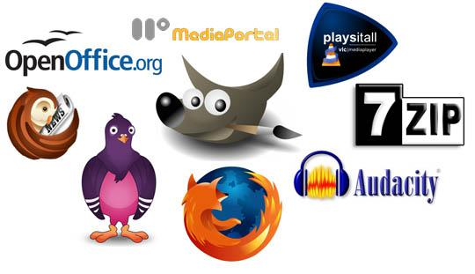

3. Open-source

These kinds of software are available to users with the source code which means that a user can freely distribute and modify the software and add additional features to the software. Open-Source software can either be free or chargeable. Some examples of open-source software are:

* Apache Web Server
* GNU Compiler Collection
* Moodle
* Mozilla Firefox
* Thunderbird

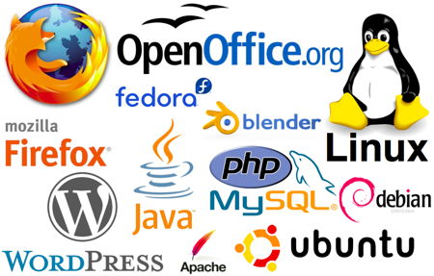

4. Software

They are also known as Closed-source software. These types of applications are usually paid and have intellectual property rights or patents over the source code. The use of these is very restricted and usually, the source code is preserved and kept as a secret.

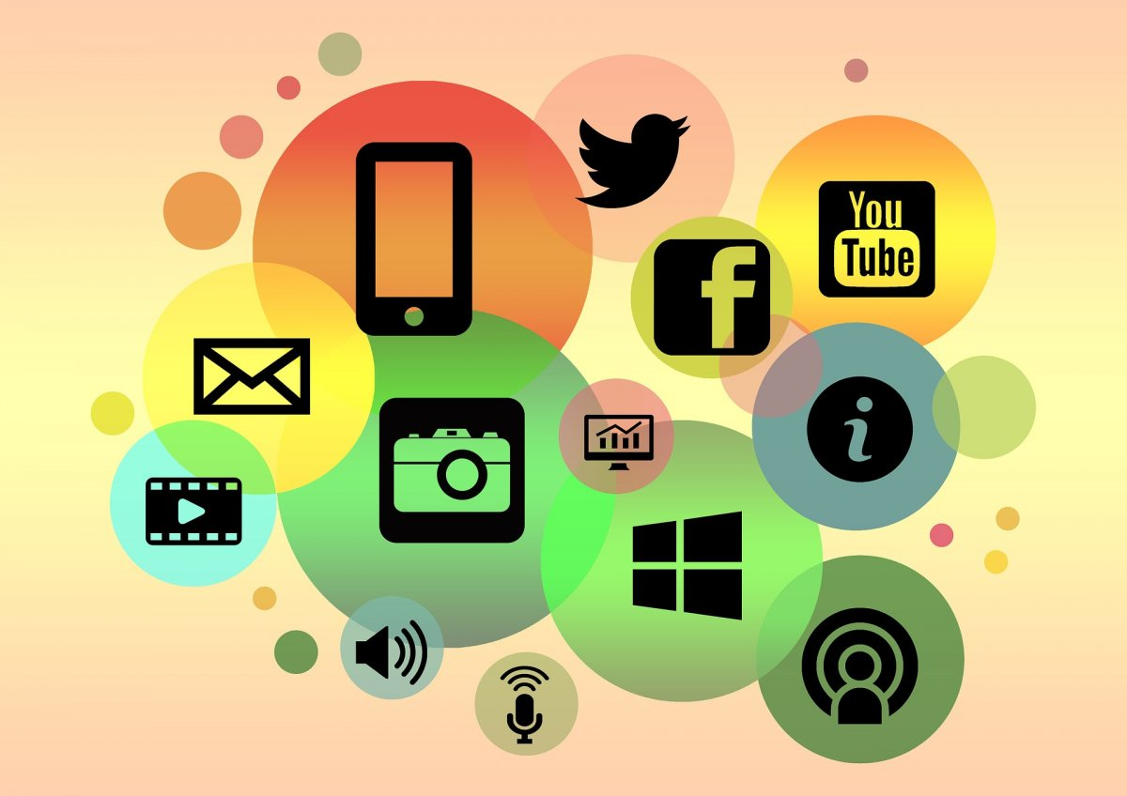

**HARDWARE VIRTUALIZATION**

Hardware virtualization is the method used to create virtual versions of physical desktops and operating systems. It uses a [virtual machine](https://www.citrix.com/solutions/vdi-and-daas/what-is-a-virtual-machine.html) manager (VMM) called a [hypervisor](https://www.citrix.com/solutions/vdi-and-daas/what-is-hypervisor.html) to provide abstracted hardware to multiple guest operating systems, which can then share the physical hardware resources more efficiently. Hardware virtualization offers many benefits, such as better performance and lower costs.

What are the components of hardware virtualization?

Hardware virtualization is structured in layers consisting of the following components:

* **The hardware layer,** or virtualization host, contains the physical server components such as CPU, memory, network, and disk drives. This is the physical hardware on which virtualization takes place. It requires an x86-based system with one or more CPUs to run all supported guest operating systems.
* **The hypervisor** creates a virtualization layer that runs between the OS and the server hardware, allowing many instances of an operating system or different operating systems to run in parallel on a single machine. Hypervisors isolate operating systems and applications from the underlying computer hardware, or the host machine, from the virtual machines that use its resources.
* **Virtual machines** are software emulations of a computing hardware environment and provide the functionalities of a physical computer. Virtual machines themselves consist of virtual hardware, a guest operating system, and guest software or applications.

## How does hardware virtualization work?

Hardware virtualization enables a single physical machine to function as multiple machines by creating simulated environments. The physical host uses software called a hypervisor that creates an abstraction layer between the software and hardware and manages the shared physical hardware resources between the guest and host operating systems. The hypervisor connects directly to the hardware and enables it to be split into multiple distinct environments or virtual machines. These VMs use the resources of the physical host, including CPU, memory, and storage, which are allocated to the guests as needed. When done for server platforms, hardware virtualization is called server virtualization. Hardware virtualization makes it possible to use a physical machine’s full capacity and, by isolating VMs from one another, to protect against [malware](https://www.citrix.com/solutions/secure-access/what-is-malware.html).

What are the different types of hardware virtualization?

***Full*** ***virtualization***

In full virtualization, the hardware architecture is completely simulated, enabling an unmodified guest operating system to be run in isolation. Data is abstracted from the underlying hardware by the virtualization layer, isolating service requests from the physical hardware that facilitates them. In this scenario, the guest operating system is unaware that it is in a virtualized environment, and therefore hardware is virtualized by the host operating system so that the guest can issue commands to what it thinks is actual hardware. However, these are just simulated hardware devices created by the host, and the hypervisor translates all OS calls. This type of virtualization isolates VMs from the host OS and one another, enabling total portability of VMs between hosts regardless of the underlying hardware.

***Paravirtualization***

In paravirtualization, the source code of an operating system is modified to run on top of a virtual machine monitor. This OS modification is required for the guest OS to communicate through calls to the API provided by the hypervisor (known as hypercalls). In this scenario, the guest OS is aware that it is a guest OS in a virtual machine environment and receives information on the other operating systems on the same physical hardware, enabling them to share resources rather than emulate an entire hardware environment. In paravirtualization, the guest OS communicates

***Operating system–level virtualization***

Managed desktops take away a big chunk of work from the IT department, as this cloud-based infrastructure is maintained and updated by the DaaS provider. With a managed desktop solution, downtime is minimized and help desk calls are considerably lowered, as resource demand does not overstress end-user devices.

***System-level virtualization***

With the simple deployment of managed desktops, IT can get temporary workers set up in relatively little time—saving hours of labor. And, IT will have full control to give your temporary employees access to only the resources they need to work.

### *Hardware-assisted virtualization*

In hardware-assisted virtualization, the computer’s physical components provide the architectural support for the virtual machine manager, or hypervisor. The combination of hardware and software allows different guest operating systems to run in isolation simultaneously on a host computer, preventing potentially harmful instructions from being executed directly on the host machine. These physical components primarily consist of the host processors, which optimize virtualization in a number of ways.

## *Citrix solutions for hardware virtualization*

[Citrix Hypervisor](https://www.citrix.com/products/citrix-hypervisor/) boosts IT flexibility with an open-source virtualization platform that enables you to manage different workload types, mixed operating systems, and complex storage or networking requirements. With Citrix Hypervisor, you can:

* Consolidate multiple VMs onto a physical server
* Reduce the number of separate disk images to be managed
* Schedule zero downtime maintenance by live migrating VMs
* Assure availability of VMs by using high availability to configure policies that restart VMs on another server in case one fails
* Increase portability of VM images